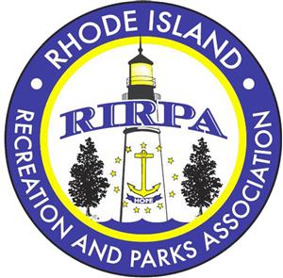
Camp University
June 17th NK Town Beach Campus
36 Beach Street North Kingstown, RI 02852
DETAILS: | ATTENDEE NEEDS:
3:45pm REGISTRATION arrive no later than 410pm | High energy!!!
7:30pm EVENT END | Appropriate foot attire
Cost: $15 per participant until 5/30 | Blanket or lawn chair (optional)
$18 per participant until 6/6 | Notebook / pen / water
You can pick your sessions! Register Online and a committee member will be in touch in June for the list of members and session requests. Limited space in each session so don’t wait to register! rirpa.myrec.com
Talk to your camp Director for more information or email cdumas@northkingstownri.gov
No City or Town will be turned away due to lack of funding. Please reach out to inquire about scholarships.

ITINERARY
  - 3:45pm REGISTRATION

  - 4:20pm START / WELCOME

  - 4:30pm-4:45pm Ice Breaker with Alison Frasier
  - 4:45pm – 4:50pm 5-minute intermission

  - 4:50pm – 5:20pm Workshop Session 1
    - Station 1 Camper Engagement and Redirection with Josh Wolff
    - Station 2 Emergency Response with NKPD & NKFD
    - Station 3 Alison Jackson Frasier’s Name Games and Getting to Know You Activities
    - Station 4 De-escalation Strategies
    - Station 5 Emotion Regulation and Self Care for Counselors

  - 5:20pm – 5:25pm 5-minute intermission

  - 5:25pm – 5:55pm Workshop 2
    - Station 1 Camper Engagement and Redirection with Josh Wolff
    - Station 2 Emergency Response with NKPD & NKFD
    - Station 3 Alison Jackson Frasier’s Circle Games

    - Station 4 De-escalation Strategies
    - Station 5 Emotion Regulation and Self Care for Counselors
  - 5:55 pm – 6:00pm 5-minute intermission

  - 6:00pm – 6:30pm Dinner boxed lunches provided by Dave’s Marketplace
  - 6:30pm -6:35pm 5-minute intermission / transition
  - 6:35-7:05 pm Workshop 3
    - Station 1 Camper Engagement and Redirection with Josh Wolff
    - Station 2 ROUNDTABLE DISCUSSION: recommended for Supervisory staff only. Moderator: Cody Clarkin
    - Station 3 Alison Jackson Frasier’s Basic Team Building Activities
    - Station 4 De-escalation Strategies
    - Station 5 Emotion Regulation and Self Care for Counselors

  - 7:05pm 7:10pm 5-minute intermission / transition
  - 7:10-7:30pm Final group fun activity with Alison Frasier

  - 7:30 pm Departure – Thank you for joining us!



Thank you to our great presenters, sponsors and committee for this great event!

US Playground Surfacing

