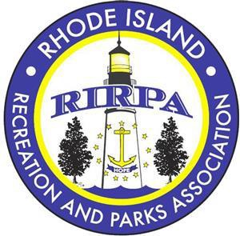RHODE ISLAND RECREATION AND PARKS ASSOCIATION 2024 PICKLEBALL GRANT 50/50 MATCH

This grant program is intended to facilitate the advancement and growth of pickleball in our local communities.

As a matching grant, your grant award will be half (50%) of your qualified cost. You can receive up to $5,000 in matching funds. All applicants must be RIRPA members. Application deadline is rolling. Recipients will be announced no later than one month after submission. Please note that all questions are required. Thank you!

Date:

Organization:
First Name: |  | Last Name:
Applicant's Work Address
Address Line 1
Address Line 2
City | State |  | ZIP Code
Email
Phone

Please describe the purpose and justification for the grant (attach additional sheets as needed)

Please specify any special attributes related to disadvantaged youths, seniors (55+), and community

(attach additional sheets as needed).

Please circle the group that is primarily being served.
General Public Students Seniors Visitors
Other (please explain)

Please provide an itemized list of proposed expenses with dollar amounts. Qualified items must be purchased by December 2024 to receive reimbursement. You will need to provide proof of payment documentation (invoices, receipts, etc.) for your project. Keep all invoices/receipts because documentation is required to receive reimbursement.

For questions and to submit this application, contact Ray DeFalco, President, Rhode Island Recreation and Parks Association at raydefalco@gmail.com.

